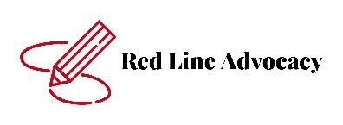
STUDENT EMERGENCY

CONTACT FORM

Name: ______________________________________________________________________________

Date of Birth: ___________

Personal Contact Info:

Home Address: _______________________________________________________________________

City, State, ZIP: _______________________________________________________________________

Home Telephone #: ____________________________ Cell #: _________________________________

Emergency Contact Info:

(1) Name: _______________________________________ Relationship: _________________________

Address: ____________________________________________________________________________

City, State, ZIP: ______________________________________________________________________

Home Telephone #: ____________________________ Cell #: _________________________________

Work Telephone #: ____________________________ Employer: ______________________________

(2) Name: _______________________________________ Relationship: _________________________

Address: ____________________________________________________________________________

City, State, ZIP: ______________________________________________________________________

Home Telephone #: ____________________________ Cell #: _________________________________

Work Telephone #: ____________________________ Employer: ______________________________

Medical Contact Info:

Doctor Name: ______________________________________ Phone #: ________________________

Dentist Name: _____________________________________ Phone #: ________________________

• I have voluntarily provided the above contact information and authorize Red Line Advocacy, LLC. and its representatives to contact any of the above on my behalf in the event of an emergency.

_____________________________________________ ______________________________
Parent/Guardian Signature Date
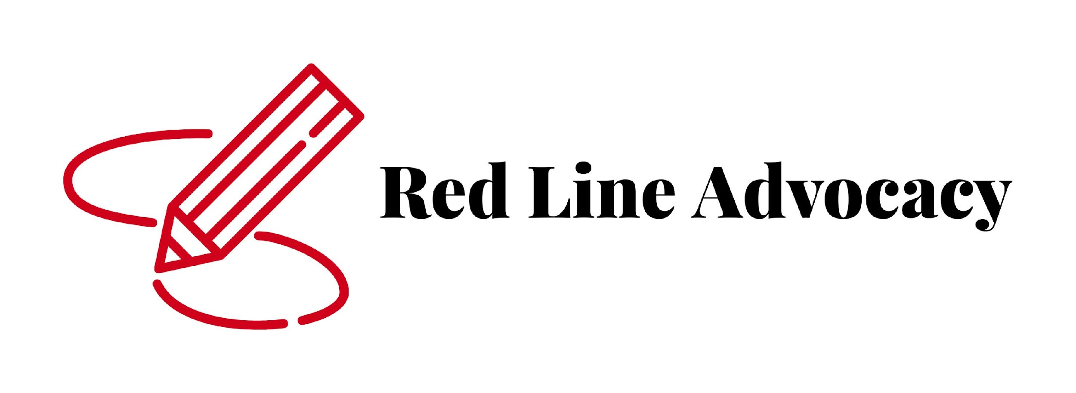
Emergency Information
Medical Release

Name of Student: ________________________________________________________

Gender: ___________ Age: _____________ Date of Birth: ____________

Address: __________________________________________ City: _______________________

State: ____________________ Zip Code: __________________

Name of Parent/Guardian: ______________________________________________________
Phone #
Work: __________________ Home: ______________________ Cell: ___________________

Email: _________________________________________

Name of Parent/Guardian: ______________________________________________________
Phone #
Work: __________________ Home: ________________________ Cell: ___________________

Email: _________________________________________

Emergency Contact with Permission to Pick up Student

Name: ________________________ Relationship: _______________Phone #: ______________
Name: ________________________Relationship: _______________Phone #: ______________
Name: ________________________ Relationship: _______________Phone #: ______________
Name: ________________________ Relationship: _______________Phone #: ______________

Name of Physician: ____________________________________ Phone #: ________________

List of Medical Conditions:
______________________________________________________________________________

List of Allergies: ______________________________________________________________________________

List of Sensitivities:
______________________________________________________________________________

List of Medications: ______________________________________________________________________________
Medical Emergency Procedures

Hospital Preference: _____________________________________________________________

These practices will be followed should it be necessary to transport a student to the hospital.

All reasonable efforts will be made to honor a hospital reference; however, in emergency situations, Red Line Advocacy, LLC will defer to any emergency medical transport personnel on the choice of hospital.

In the event of a serious Medical Emergency involving an illness or injury, the child will be transported to a hospital emergency department. In such circumstances, a diligent effort will be made to contact parents, other designated individuals, or the child’s physician. To deal with a circumstance in which a child experiences a serious Medical Emergency where neither parent nor guardian can be reached, Red Line Advocacy, LLC requires that the following Medical Consent be signed. This is intended to facilitate prompt medical attention for a child in the event that parents or guardians are not present or cannot be reached to give authorization for emergency medical treatment. The completion of this form will not preclude the attempt to notify promptly parent or the child’s physician, but is intended to allow emergency medical transport personnel, physicians, and/or hospital personnel to initiate prompt care when most needed in the event of a Medical Emergency.

Medical Consent
Name of Student: ______________________________________________________
In the event of a serious medical emergency, Authorized Red Line Advocacy, LLC personnel have my permission to have the named child transported to a hospital emergency department.

I further give my permission to the emergency transport personnel, physicians, and/or hospital emergency department personnel where my child is taken, to treat the above named child in an emergency situation.

_________________________________________ __________________________
Signature of Custodial Parent or Guardian Date

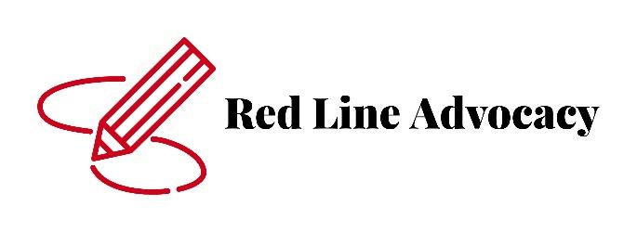
CONSENT FOR THE RELEASE/OBTAIN OF INFORMATION
Student Name: __________________________________________________________
Date of Birth: _______________________
Parent/Guardian’s Name: __________________________________________________
Address: _______________________________ City: ______________________
State: ____________ Zip code: _____________
Home Phone Number: ____________________ Cell Phone Number: ___________________
I authorize Red Line Advocacy, LLC. to release/obtain information to, obtain information from and communicate with:
Name: ___________________________________________________________
Address: ________________________________ City: _______________________
State: _____________ Zip code: _____________
Title: _______________________________
Phone Number: _________________________ Fax Number: _________________________
Please select the information you would like released.
- Academic Records
- Special education records
- Assessments and recommendations by the above-named person or agency
- Verbal communication
- Medical records
- Other (please specify): ____________________________________________
I understand that all information is confidential and cannot be released without written permission of the parent or legal guardian.
_________________________________ _____________________
Parent/Guardian Signature Date

_________________________________ ______________________
Relationship to Student Date School Received
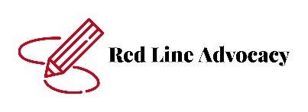
Medication Administration Authorization
Student’s Information
Name of Facility/School ________________________________________
Today’s Date ___/___/____
Name of Child (First and Last) ___________________________________
Date of Birth ___/___/____
Name of Medication ______________________________________________________
Reason Medication is needed during school hours ___________________________________________
Dose ________________________ Route ____________________________
Time to give Medication _____________________________
Additional Instructions ______________________________________________________________________
Date to start medication ___/___/____ Date to end medication ___/___/____
Known side effects of medication _____________________________________________________________
Plan of management of side effects ___________________________________________________________
Student Allergies __________________________________________________________________________

Prescriber’s Information
Prescribing Health Professional’s Name __________________________________________________
Phone Number _________________________

Permission to Give Medication
I hereby give permission for Red Line Advocacy, LLC. to administer medicine as prescribed above. I also give permission for the caregiver/teacher to contact the prescribing professional about the administration of this medication. I have administered at least one dose of medicine to my student without adverse effects.
Parent or Guardian Name (Print) ______________________________________________________________
Parent or Guardian Signature ________________________________________________________________
Address _________________________________________________________________________________
Home Phone Number ____________________
Work Phone Number _____________________
Cell Phone Number _______________________

Student Media Release Form

Student Name: ________________________________________________________

Red Line Advocacy, LLC requests that each parent/guardian check one of the options listed below. Please sign the section that represents your wishes and return this permission slip to Red Line Advocacy, LLC.

_____ I agree to have my child’s work, name, or image used for program media purposes. Media may be in the form of a public newspaper, radio, television, social media, or website.

Parent/Guardian Name (please print): _______________________________________

Parent/Guardian Signature: ______________________________ Date: ____________

_____ I do not wish to have my child’s work, name, or image published in any program-related media, including a recognizable image, still or video, original work created by me, or use of my name in connection with said image, in a local newspaper, news broadcast, social media, or on Red Line Advocacy, LLC website in connection with any event, award, or activity. *

Parent/Guardian Name (please print): ________________________________________

Parent/Guardian Signature: _____________________________Date: ____________

* Note: If your child’s name or picture accidentally appears on the program’s web site or social media, please contact Brandie Hazelett immediately and it will be removed. Thank you.

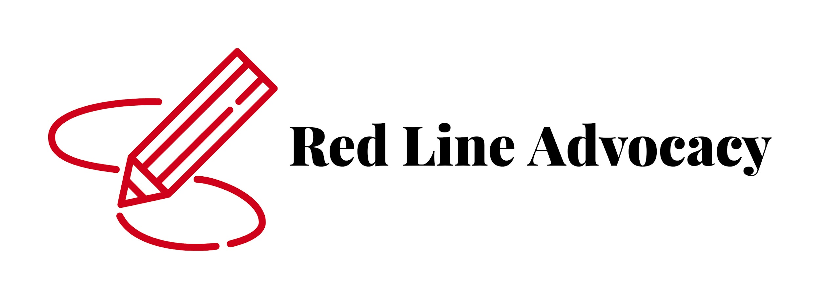
Outing Permission

I,_____________________(Parent/guardian)

(Circle One)
give do not give

permission for my student _______________________ to attend and participate in social and vocational outings. I also understand that my student may be required to wear a mask as a requirement of the site where the outing is taking place and I give permission for RLA to require a mask as required by the site or facility. I understand that I can change this permission at any time.

Parent Guardian Signature _____________________________Date___________________

Administrative Signature _____________________________Date___________________

Parent Information and Acknowledgement Regarding COVID-19
As of August 11, 2022 guidelines from the Centers for Disease Control and Ohio Department of Health are as follows (SEE FOLLOWING PAGES):

Please sign and return the last page of this packet to school.

I_________________(Parent/guardian) understand that these recommendations apply to my student ____________________. I understand that Red Line Advocacy has policies regarding temperature checks and symptoms and my student will be required to go home after demonstrating a temperature of 100℉ or higher OR acute respiratory infection symptoms. Red Line Advocacy is required by the Ohio Department of Education to refer me to a healthcare provider and/or COVID-19 Testing Site.

Parent Guardian Signature _____________________________Date___________________

Administrative Signature _____________________________Date________________

